ONLINE PORTFOLIO

Project description

In today's digital age, showcasing my creative work is crucial to advance my career. An online portfolio can help me market my skills and abilities to potential employers or clients. This project aims to create an online portfolio that highlights my creative work, skills, and experience in a professional and engaging manner.

My online portfolio is a digital showcase of my professional accomplishments, skills, and expertise. It serves as an online representation of my work that is easily accessible for potential clients, employers, and collaborators. The portfolio is designed to be visually appealing and easy to navigate, with a responsive design optimized for desktop.

The home page of my portfolio provides a brief introduction about myself. The about me page provides a introduction about my skills, and my areas of expertise. It also highlights my recent work and notable accomplishments. Visitors can navigate through different sections of the portfolio to delve deeper into my work, experience, and achievements.

My portfolio includes a diverse range of projects that showcase my abilities in various areas of my field. I make sure to include visuals such as photos, videos, or screenshots that represent the project in the best possible way.

The portfolio also includes a resume and links to relevant online profiles such as LinkedIn or GitHub, and this portfolio also includes links to my social media accounts. By providing easy access to my professional profile, visitors can gain a more comprehensive understanding of my experience, qualifications, and skills.

Overall, my online portfolio is an essential tool in presenting myself as a professional in my field. It highlights my strengths, achievements, and experience in a visual and engaging format that is accessible to anyone. It is my go-to platform for sharing my work and skills and is a valuable asset in helping me achieve my career goals.

code

Index.html

<!DOCTYPE html>

<html lang="en">

<head>

<meta charaset="UTF-8">

<meta http-equiv="X-UA-Compatible" content="IE-edge">

<meta name="viewport" content="width=device-width, initial-scale=1.0">

<title>personal portfolio</title>

<link rel="stylesheet" href="style.css"></link>

<script src="https://kit.fontawesome.com/38eb5f35af.js" crossorigin="anonymous"></script>

</head>

<body>

<div id="header">

<div class="container">

<nav>

<img src="images/log.png" class="logo">

<ul>

<li><a href="index.html">Home</a></li>

<li><a href="about.html">About</a></li>

<li><a href="services.html">Services</a></li>

<li><a href="portfolio.html">Portfolio</a></li>

<li><a href="contact.html">Contact</a></li>

</ul>

</nav>

<div class="header-text">

<p>Lifestyle Creator</p>

<h1> Hi, I'm <span>ISHITA</span> </h1><h3>from MADHYA PRADESH</h3>

</div>

</div>

</div>

</body>

</html>

About.html

<!DOCTYPE html>

<html lang="en">

<head>

<meta charaset="UTF-8">

<meta http-equiv="X-UA-Compatible" content="IE-edge">

<meta name="viewport" content="width=device-width, initial-scale=1.0">

<title>personal portfolio</title>

<link rel="stylesheet" href="style.css"></link>

<script src="https://kit.fontawesome.com/38eb5f35af.js" crossorigin="anonymous"></script>

</head>

<body>

<nav>

<img src="images/log.png" class="logo">

<ul>

<li><a href="index.html">Home</a></li>

<li><a href="about.html">About</a></li>

<li><a href="services.html">Services</a></li>

<li><a href="portfolio.html">Portfolio</a></li>

<li><a href="contact.html">Contact</a></li>

</ul>

<style>

body{

background-image: url("./images/back.png");

}

</style>

</nav>

<!--- -----------about--------- -->

<div id="about">

<div class="container">

<div class="row">

<div class="about-col-1">

<img src="images/ishita.jpg">

</div>

<div class="about-col-2">

<h1 class="sub-title">About ISHITA</h1>

<p>Popular for her relatable fashion and girl-next-door personality, Ishita Khanna has paved her own niche in the fast-paced digital space.

Her knack to connect with the audience through the camera has resulted in her immense social media presence.

From being an Economics graduate to a UPSC aspirant to pursuing her passion and becoming a full-time content creator,

Ishita has been a believer of hard work and hustle. Be it Fashion, Beauty, Travel or Lifestyle,

she strives to be both honest and entertaining in the content she meticulously crafts. </p> <div class="tab-titles">

<p class="tab-links active-link" onclick="opentab('skills')">Skills</p>

<p class="tab-links" onclick="opentab('experience')">Experience</p>

<p class="tab-links" onclick="opentab('education')">Education</p>

</div>

<div class="tab-contents active-tab" id="skills">

<ul>

<li><span>Youtube Creator</span><br>Full-Time Youtube Creator</li>

<li><span>Freelancing</span><br>Full-Time work as a Social Media Manager</li>

<li><span>Indian Content Creator</span><br>Fashion,Lifestyle and Styling</li>

</ul>

</div>

<div class="tab-contents" id="experience">

<ul>

<li><span>Jul 2019 - Present</span><br>YouTube Creator</li>

<li><span>Nov 2019 - Nov 2020</span><br>Social Media Manager at Good Times</li>

<li><span>Aug 2018 - Oct 2019</span><br>Senior Content Creator at MUSEBRIDGE SYSTEMS PRIVATE LIMITED</li>

</ul>

</div>

<div class="tab-contents" id="education">

<ul>

<li><span>2003 - 2011</span><br>Welham Girls School, Dehradun</li>

<li><span>2011 - 2014</span><br>St. Xavier's College<br>Bachelor of Arts - BA</li>

<li><span>2014 - 2017</span><br>Gokhale Institute of Politics and Economics <br>Master's degree - Economics</li>

</ul>

</div>

</div>

</div>

</div>

</div>

<script>

var tablinks = document.getElementsByClassName("tab-links");

var tabcontents = document.getElementsByClassName("tab-contents");

function opentab(tabname){

for(tablink of tablinks){

tablink.classList.remove("active-1ink");

}

for(tabcontent of tabcontents){

tabcontent.classList.remove("active-tab");

}

event.currentTarget.classList.add("active-1ink");

document.getElementById(tabname).classList.add("active-tab");

}

</script>

</body>

</html>

Services.html

<!DOCTYPE html>

<html lang="en">

<head>

<meta charaset="UTF-8">

<meta http-equiv="X-UA-Compatible" content="IE-edge">

<meta name="viewport" content="width=device-width, initial-scale=1.0">

<title>personal portfolio</title>

<link rel="stylesheet" href="style.css"></link>

<script src="https://kit.fontawesome.com/38eb5f35af.js" crossorigin="anonymous"></script>

</head>

<body>

<nav>

<img src="images/log.png" class="logo">

<ul>

<li><a href="index.html">Home</a></li>

<li><a href="about.html">About</a></li>

<li><a href="services.html">Services</a></li>

<li><a href="portfolio.html">Portfolio</a></li>

<li><a href="contact.html">Contact</a></li>

</ul>

<style>

body{

background-image: url("./images/back5.png");

}

</style>

</nav>

<!-- ----------services------------ -->

<div id="services">

<div class="container">

<h1 class="sub-title">Services by Ishita</h1>

<div class="services-list">

<div>

<i class="fa-brands fa-youtube"></i>

<h2> Youtube Creator </h2>

<p>Her YouTube is a collection of hauls, skincare and

makeup, vlogs, fashion/styling, girl talks, and must-haves!</p>

<a href="https://www.youtube.com/@IshitaKhanna">Learn more</a>

</div>

<div>

<i class="fa-solid fa-photo-film"></i>

<h2> Content Creator </h2>

<p>Digital creator,Ishita Khanna She is Creative and innovative,

with a penchant for fashion, styling, and lifestyle.</p>

<a href="https://www.instagram.com/ishitakhannaofficial/">Learn more</a>

</div>

<div>

<i class="fa-regular fa-thumbs-up"></i>

<h2> Freelancing </h2>

<p>she is a Full-Time Freelancer and works as a Social Media Manager</p>

<a href="https://www.linkedin.com/in/ishita-khanna-6159b3136/">Learn more</a>

</div>

</div>

</div>

</div>

</body>

</html>

Portfolio.html

<!DOCTYPE html>

<html lang="en">

<head>

<meta charaset="UTF-8">

<meta http-equiv="X-UA-Compatible" content="IE-edge">

<meta name="viewport" content="width=device-width, initial-scale=1.0">

<title>personal portfolio</title>

<link rel="stylesheet" href="style.css"></link>

<script src="https://kit.fontawesome.com/38eb5f35af.js" crossorigin="anonymous"></script>

</head>

<body>

<nav>

<img src="images/log.png" class="logo">

<ul>

<li><a href="index.html">Home</a></li>

<li><a href="about.html">About</a></li>

<li><a href="services.html">Services</a></li>

<li><a href="portfolio.html">Portfolio</a></li>

<li><a href="contact.html">Contact</a></li>

</ul>

<style>

body{

background-image: url("./images/back5.png");

}

</style>

</nav>

<!--------------------portfolio------------------>

<div id="portfolio">

<div class="container">

<h1 class="sub-title">ISHITA'S WORK</h1>

<div class="work-list">

<div class="work">

<img src="images/ishi (1).jpg">

<div class="layer">

<h3> Myntra </h3>

<p>Get Your Daily Dose of Fashion from Ishita Khanna</p>

<a href="https://www.myntra.com/studio/influencer/1d8d66c1.939a.4ac6.a6b8.73dbcc1de9d0g0410qkloq/ishita-khanna?appRoute=%7B%22url%22%3A%22%2Fstudio%2Finfluencer%2F1d8d66c1.939a.4ac6.a6b8.73dbcc1de9d0g0410qkloq%2Fishita-khanna%22%7D"><i class="fa-solid fa-square-up-right"></i></a>

</div>

</div>

<div class="work">

<img src="images/ishi (4).jpg">

<div class="layer">

<h3> The Talented Indian</h3>

<p> An Interview with Ishita Khanna, a YouTuber and digital creator, who brings her viewers the best of fashion and lifestyle tips. </p>

<a href="https://www.thetalentedindian.com/fashion-lifestyle-and-styling-meet-the-youtuber-ishita-khanna/"><i class="fa-solid fa-square-up-right"></i></a>

</div>

</div>

<div class="work">

<img src="images/ishi (6).jpg">

<div class="layer">

<h3> a TEDx Connaught Place talk</h3>

<p> Money as a means to an end: a TEDx Connaught Place talk by Ishita Khanna on Ecosphere's work in Spiti</p>

<a href="https://www.indiawaterportal.org/articles/money-means-end-tedx-connaught-place-talk-ishita-khanna-ecospheres-work-spiti"><i class="fa-solid fa-square-up-right"></i></a>

</div>

</div>

</div>

<a href="https://www.youtube.com/@IshitaKhanna" class="btn">SEE MORE</a>

</div>

</div>

<script>

var tablinks = document.getElementsByClassName("tab-links");

var tabcontents = document.getElementsByClassName("tab-contents");

function opentab(tabname){

for(tablink of tablinks){

tablink.classList.remove("active-1ink");

}

for(tabcontent of tabcontents){

tabcontent.classList.remove("active-tab");

}

event.currentTarget.classList.add("active-1ink");

document.getElementById(tabname).classList.add("active-tab");

}

</script>

</body>

</html>

contact.html

<!DOCTYPE html>

<html lang="en">

<head>

<meta charaset="UTF-8">

<meta http-equiv="X-UA-Compatible" content="IE-edge">

<meta name="viewport" content="width=device-width, initial-scale=1.0">

<title>personal portfolio</title>

<link rel="stylesheet" href="style.css"></link>

<script src="https://kit.fontawesome.com/38eb5f35af.js" crossorigin="anonymous"></script>

</head>

<body>

<nav>

<img src="images/log.png" class="logo">

<ul>

<li><a href="index.html">Home</a></li>

<li><a href="about.html">About</a></li>

<li><a href="services.html">Services</a></li>

<li><a href="portfolio.html">Portfolio</a></li>

<li><a href="contact.html">Contact</a></li>

</ul>

<style>

body{

background-image: url("./images/back5.png");

}

</style>

</nav>

<!----------------contact----------->

<div id="contact">

<div class="container">

<div class="row">

<div class="contact-left">

<h1 class="sub-title">CONTACT <span>ISHITA</span></h1>

<p><i class="fa-regular fa-paper-plane"></i> ishita.khanna@hotmail.com</p>

<div class="social-icons">

<a href="https://www.facebook.com/ishitakhanna1793/"><i class="fa-brands fa-facebook"></i></a>

<a href="https://twitter.com/ishitakhanna?lang=en"><i class="fa-brands fa-square-twitter"></i></a>

<a href="https://www.instagram.com/ishitakhannaofficial/"><i class="fa-brands fa-instagram"></i></a>

<a href="https://www.linkedin.com/in/ishita-khanna-6159b3136/"><i class="fa-brands fa-linkedin"></i></a>

</div>

<a href="" class="btn btn2">Download CV</a>

</div>

<div class="contact-right">

<form name="submit-to-google-sheet">

<input type="text" name="Name" placeholder="Your Name" required>

<input type="email" name="Email" placeholder="Your Email" required>

<textarea name="Message" rows="6" placeholder="Your Message"></textarea>

<button type="submit" class="btn btn2">SUBMIT</button>

</form>

<span id="msg"></span>

</div>

</div>

</div>

<div class="copyright">

<p>Copyright <i class="fa-regular fa-copyright"></i> SUHA. Made with <i class="fa-solid fa-heart"></i> </p>

</div>

</div>

<script>

var tablinks = document.getElementsByClassName("tab-links");

var tabcontents = document.getElementsByClassName("tab-contents");

function opentab(tabname){

for(tablink of tablinks){

tablink.classList.remove("active-1ink");

}

for(tabcontent of tabcontents){

tabcontent.classList.remove("active-tab");

}

event.currentTarget.classList.add("active-1ink");

document.getElementById(tabname).classList.add("active-tab");

}

</script>

<script>

const scriptURL = 'https://script.google.com/a/macros/citchennai.net/s/AKfycbxARnlCg1DVC_A2JyQjDRExfZSGvbQx4thYncNjWvNgB65SOJ44a5AtU0vUoRWgrhmd/exec'

const form = document.forms['submit-to-google-sheet']

const msg = document.getElementById("msg")

form.addEventListener('submit', e => {

e.preventDefault()

fetch(scriptURL, { method: 'POST', body: new FormData(form)})

.then(response => {

msg.innerHTML = "Message sent Successfully"

setTimeout(function(){

msg.innerHTML =""

},5000)

form.reset

})

.catch(error => console.error('Error!', error.message))

})

</script>

</body>

</html>

Style.css

*{

margin: 0;

padding: 0;

font-family: 'Poppins', 'Lucida Sans', 'Lucida Sans Regular', 'Lucida Grande', 'Lucida Sans Unicode', 'Geneva', Verdana, sans-serif;

box-sizing: border-box;

}

html{

scroll-behavior: smooth;

}

body{

background: #926E48;

color: #fff;

}

#header{

width: 100%;

height: 100vh;

background-image: url(images/background.png);

background-size: cover;

background-position: center;

}

.container{

padding: 25px 10%;

}

nav{

display: flex;

align-items: center;

justify-content: space-between;

flex-wrap: wrap;

}

.logo{

width: 150px;

padding: 5px;

}

nav ul li{

display: inline-block;

list-style: none;

margin: 10px 20px;

}

nav ul li a{

color: #fff;

text-decoration: none;

font-size: 20px;

position: relative;

}

nav ul li a::after{

content: '';

width: 0%;

height: 3px;

background: #ffa600;

position: absolute;

left: 0;

bottom: -6px;

transition: 0.5s;

}

nav ul li a:hover::after{

width: 100%;

}

.header-text{

margin-top: 20%;

font-size: 30px;

}

.header-text h1{

font-size: 60px;

margin-top: 20px;

}

.header-text h1 span{

color: #ffa600;

}

/* --------------about------------------*/

#about{

padding: 20px 0;

color: #ffffff;

}

.row{

display: flex;

justify-content: space-between;

flex-wrap: wrap;

}

.about-col-1{

flex-basis: 35%;

}

.about-col-1 img{

width: 100%;

border-radius: 15px;

}

.about-col-2{

flex-basis: 60%;

}

.subtitle{

font-size: 60px;

font-weight: 600;

color: #fff;

}

.tab-titles{

display: flex;

margin: 20px 0 40px;

}

.tab-links{

margin-right: 50px;

font-size: 18px;

font-weight: 500;

cursor: pointer;

position: relative;

}

.tab-links::after{

content: '';

width: 0%;

height: 3px;

background: #ffa600;

position: absolute;

left: 0;

bottom: -6px;

transition: 0.5s;

}

.tab-links:hover::after{

width: 100%;

}

.tab-contents ul li{

list-style: none;

margin: 10px 0;

}

.tab-contents ul li span{

color: #ffa600;

font-size: 14px;

}

.tab-contents{

display: none;

}

.tab-contents.active-tab{

display: block;

}

/*--------------------services---------------------*/

#services{

padding: 30px 0;

font-size: 28px;

}

.services-list{

display: grid;

grid-template-columns: repeat(auto-fit, minmax(250px,1fr));

grid-gap: 40px;

margin-top: 50px;

}

.services-list div{

background: #382711;

padding: 50px;

font-size: 15px;

font-weight: 200;

border-radius: 10px;

transition: background 0.5s, transform 0.5s;

}

.services-list div i{

font-size: 40px;

margin-bottom: 30px;

}

.services-list div h2{

font-size: 27px;

font-weight: 500;

margin-bottom: 15px;

}

.services-list div a{

text-decoration: none;

color: #fff;

font-size: 15px;

margin-top: 20px;

display: inline-block;

}

.services-list div:hover{

background: #ffa600;

transform: translateY(-10px);

}

/* --------------portfolio--------- */

#portfolio{

padding: 0px 0;

}

.work-list{

display: grid;

grid-template-columns: repeat(auto-fit, minmax(250px, 1fr));

grid-gap: 40px;

margin-top: 50px;

}

.work{

border-radius: 10px;

position: relative;

overflow: hidden;

}

.work img{

width: 100%;

border-radius: 10px;

display: block;

transition: transform 0,5s;

}

.layer{

width: 100%;

height: 0;

background: linear-gradient(rgba(0,0,0,0.6),#ffc559);

border-radius: 10px;

position: absolute;

left: 0;

bottom: 0;

overflow: hidden;

display: flex;

align-items: center;

justify-content: center;

flex-direction: column;

padding: 0 40px;

text-align: center;

font-size: 14px;

transition: height 0.5s;

}

.layer h3{

font-weight: 500;

margin-bottom: 20px;

}

.layer a{

margin-top: 20px;

color: #ffa600;

text-decoration: none;

font-size: 18px;

line-height: 60px;

background: #fff;

width: 60px;

height: 60px;

border-radius: 50%;

text-align: center;

}

.work:hover img{

transform: scale(1.1);

}

.work:hover .layer{

height: 100%;

}

.btn{

display: block;

margin: 50px auto;

width: fit-content;

border: 1px solid #ffa600;

padding: 14px 50px;

border-radius: 6px;

text-decoration: none;

color: #fff;

transition: background 0.5s;

}

.btn:hover{

background: #ffa600;

}

/* -------------contact----------- */

.contact-left{

flex-basis: 35%;

}

.contact-right{

flex-basis: 60%;

}

.contact-left p{

margin-top: 20px;

}

.contact-left p i{

color: #fff;

margin-right: 15px;

font-size: 25px;

}

.social-icons{

margin-top: 30px;

}

.social-icons a{

text-decoration: none;

font-size: 30px;

margin-right: 15px;

color: #fff;

display: inline-block;

transition: transform 0.5s;

}

.social-icons a:hover{

color: #382711;

transform: translateY(-5px);

}

.btn.btn2{

display: inline-block;

background: #fcaf20;

}

.contact-right form{

width: 100%;

}

form input,form textarea{

width: 100%;

border: 0;

outline: none;

background: #262626;

padding: 15px;

margin: 15px 0;

color: #fff;

font-size: 18px;

border-radius: 6px;

}

form .btn2{

padding: 14px 60px;

font-size: 18px;

margin-top: 20px;

cursor: pointer;

}

.copyright{

width: 100%;

text-align: center;

padding: 25px 0;

background: #262626;

font-weight: 300;

margin-top: 0px;

}

.copyright i{

color: #ffa600;

}

#msg{

color: #61b752;

margin-top: -40px;

display: block;

}

Output:

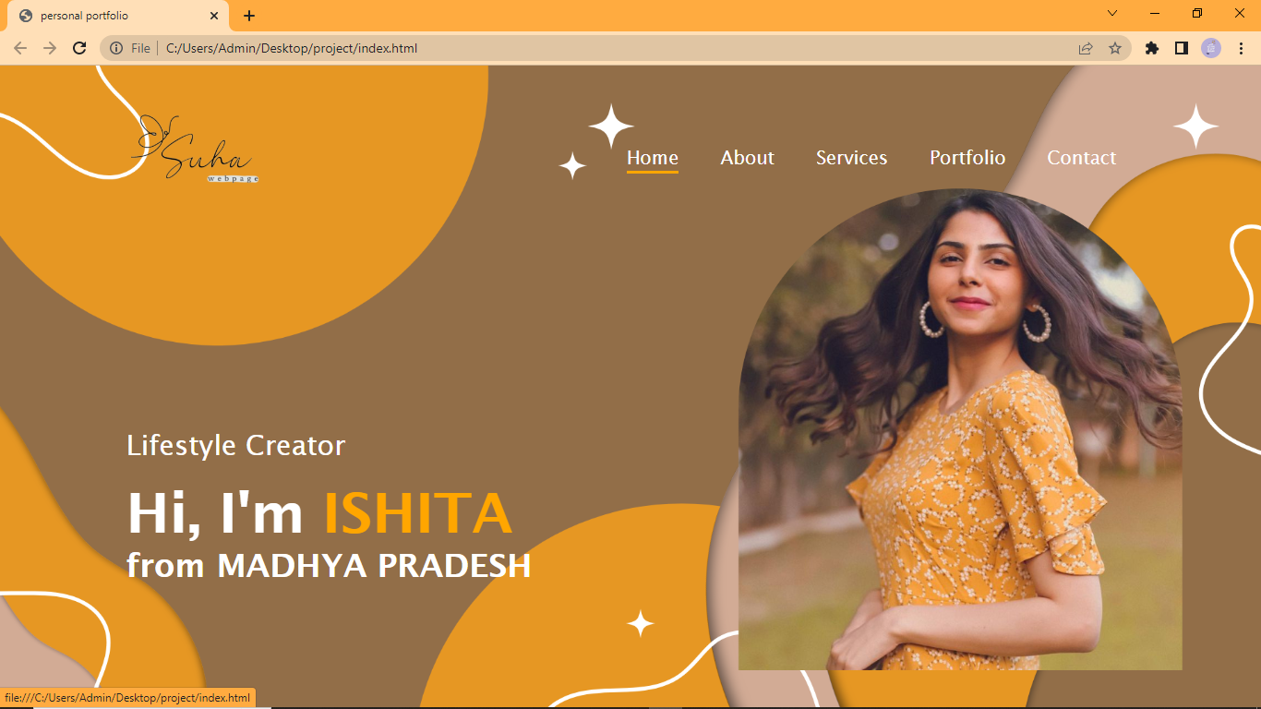

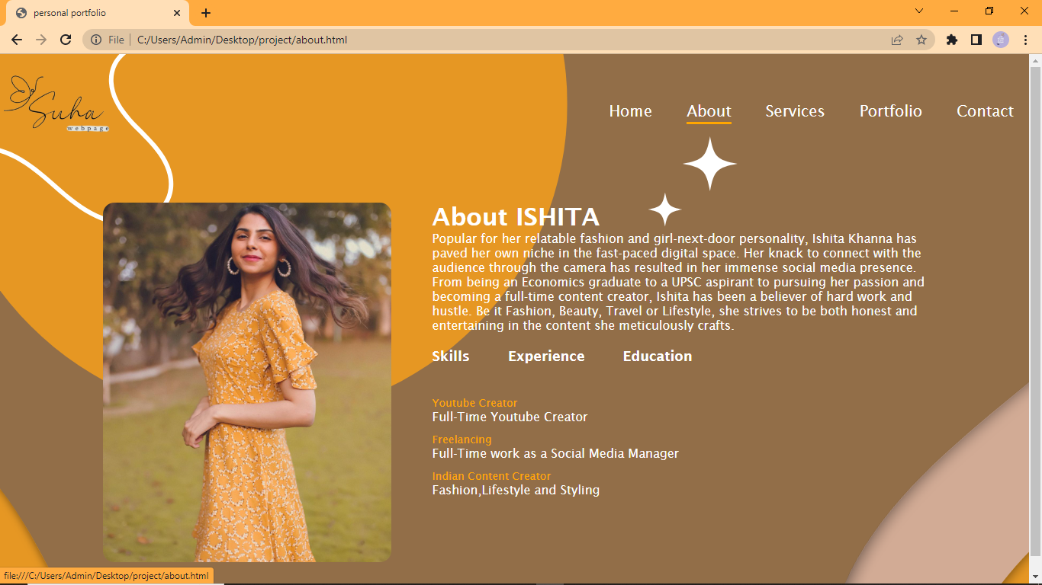

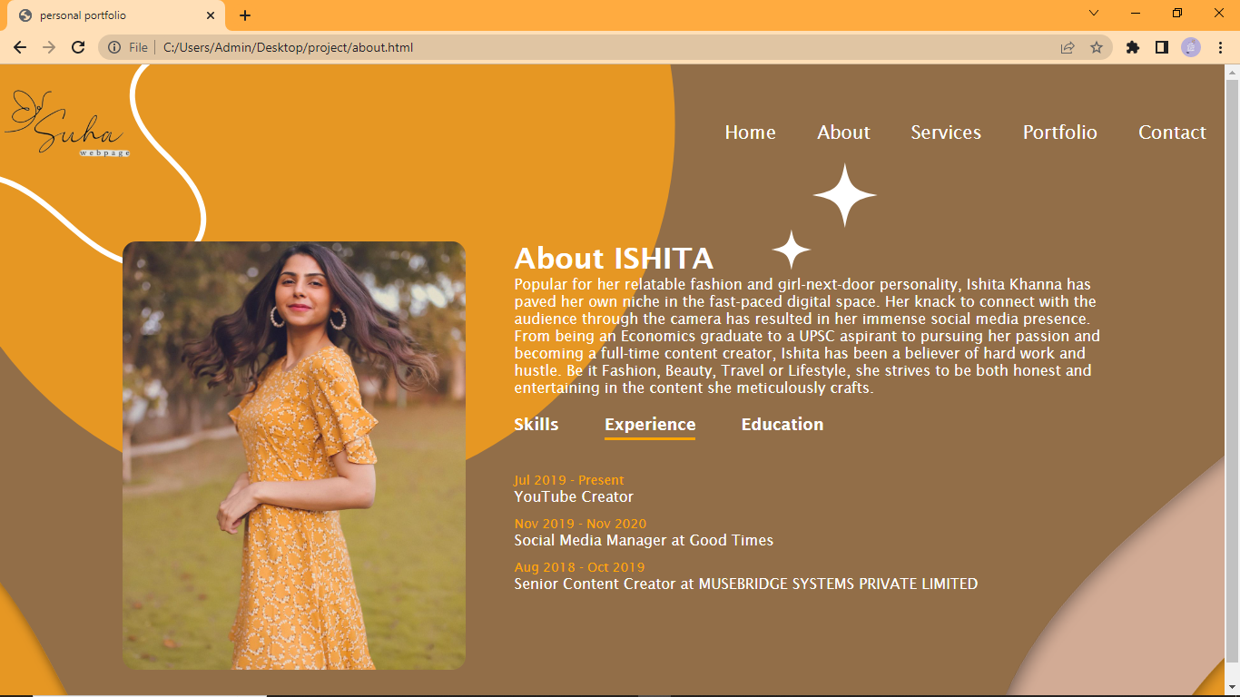

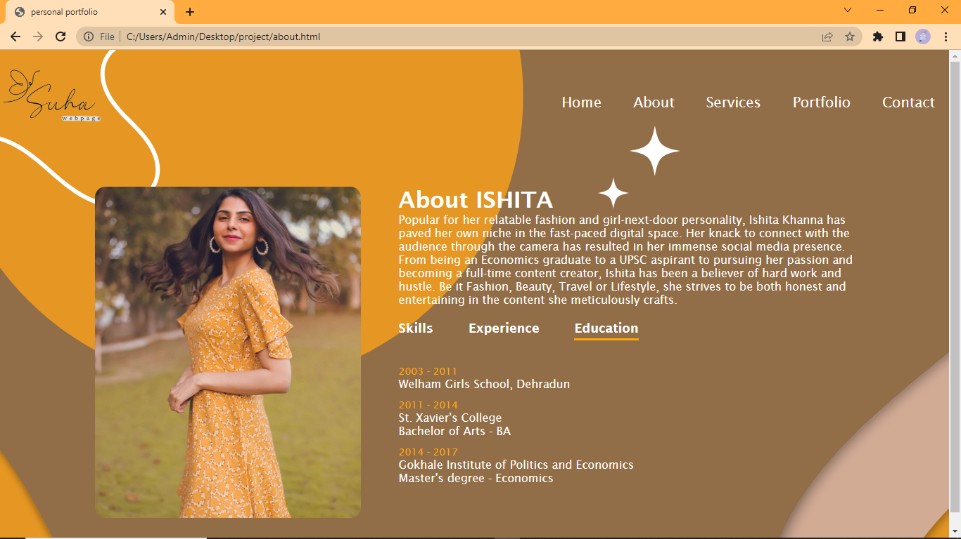

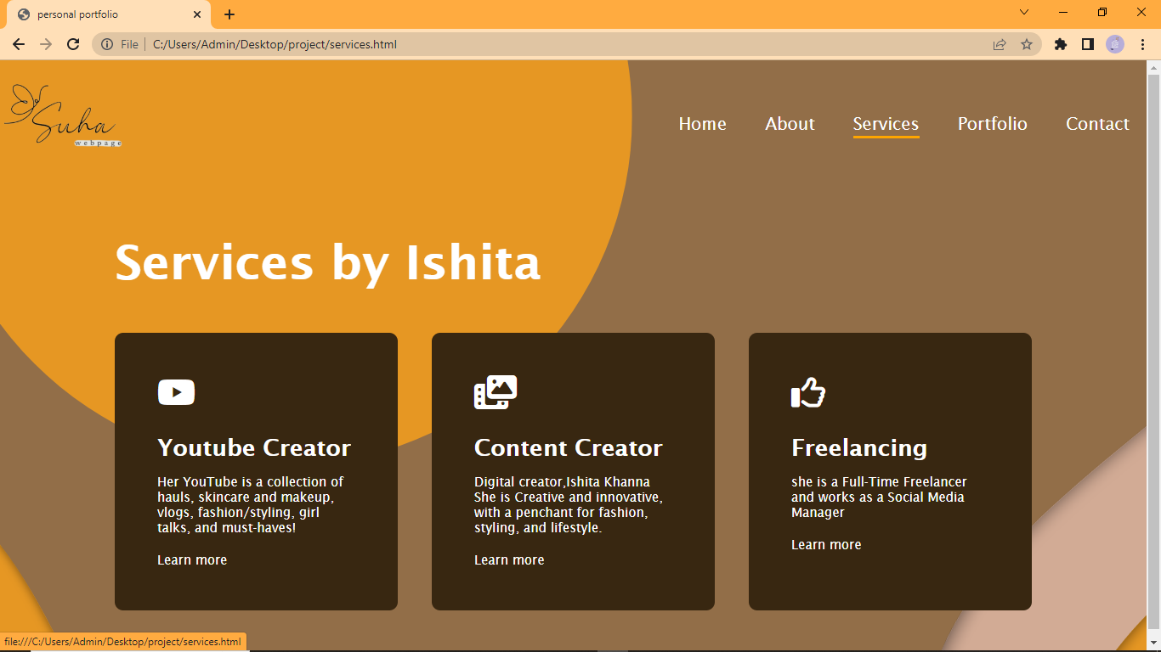

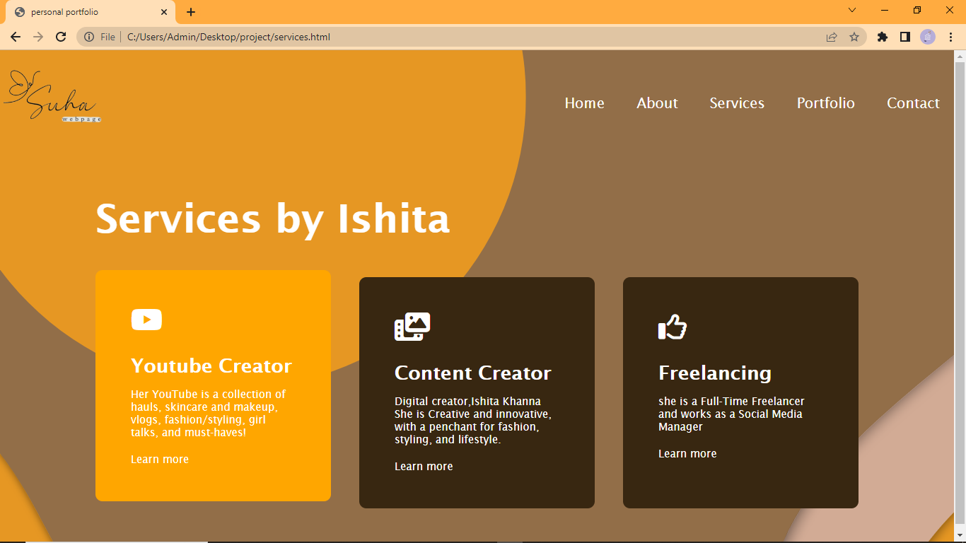

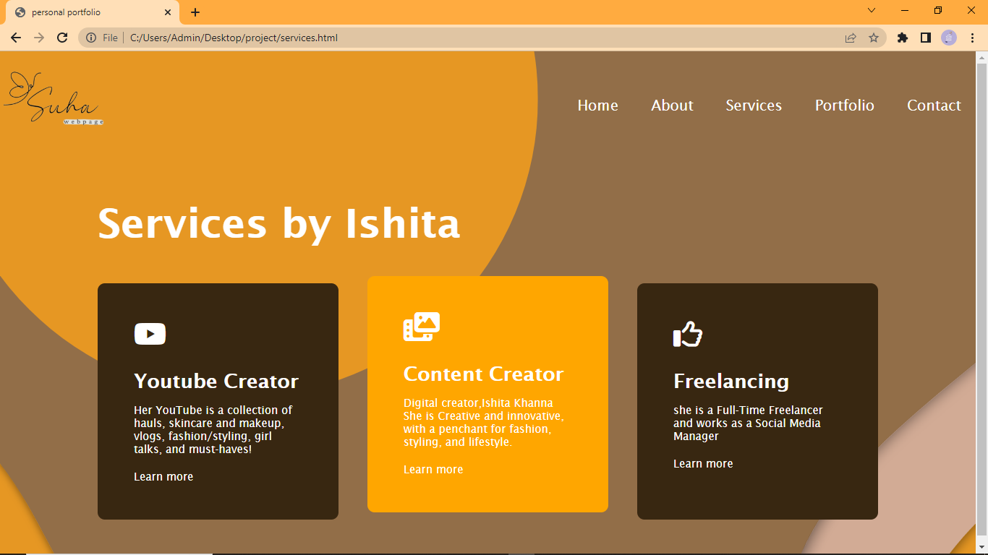

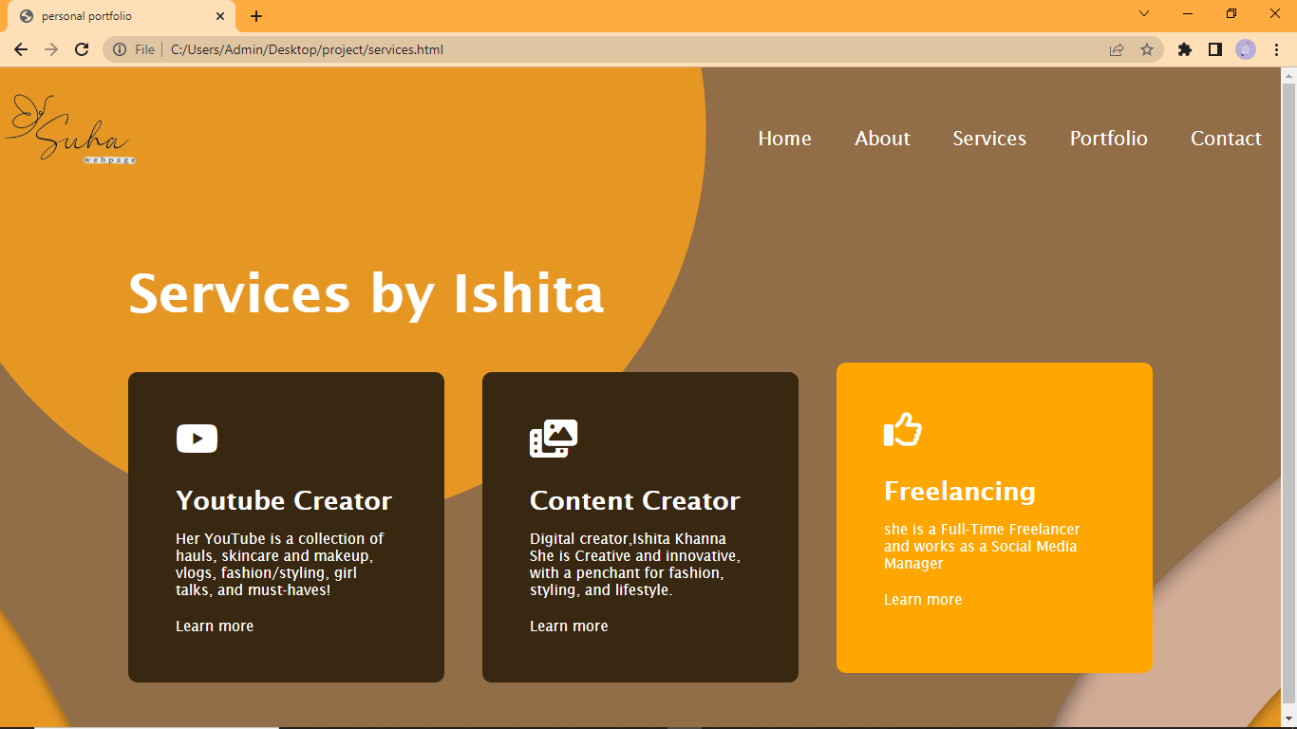

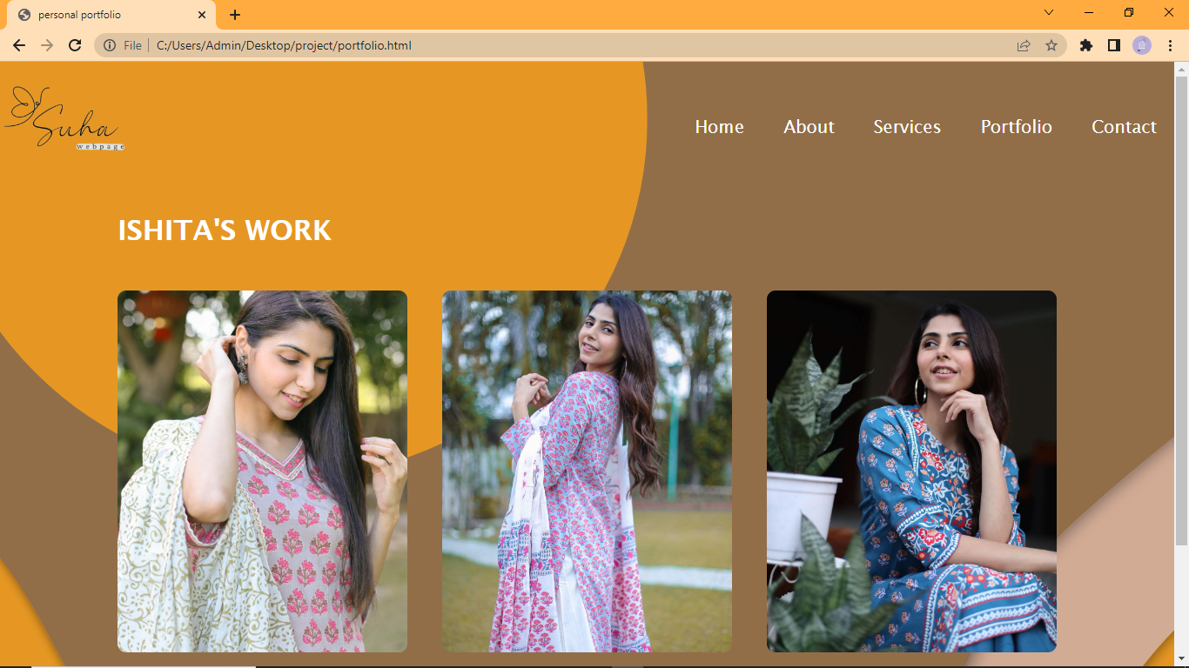

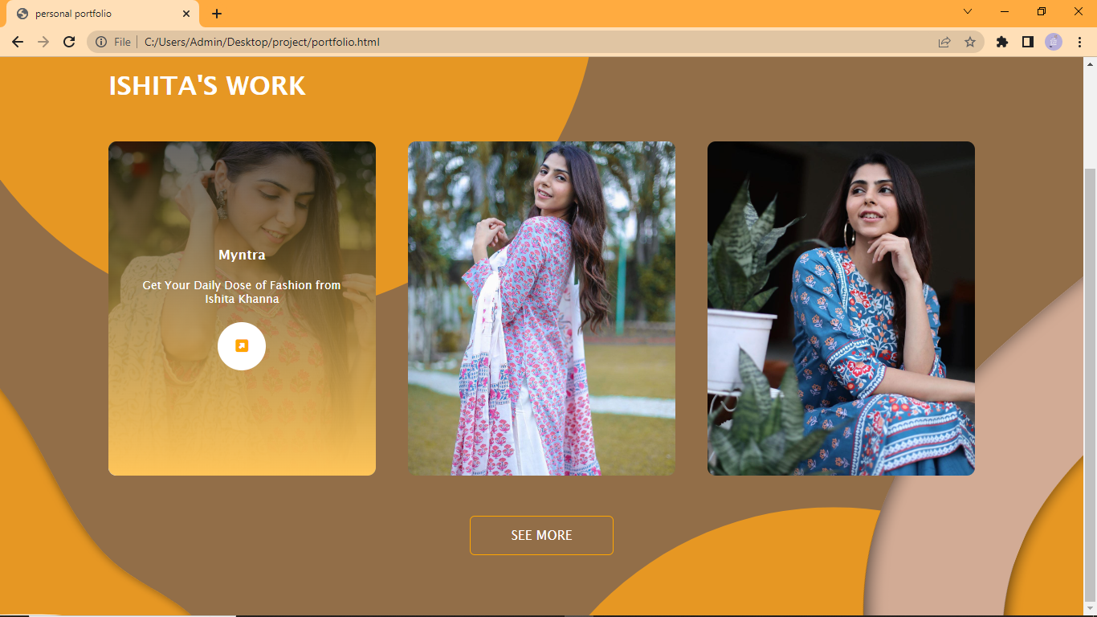

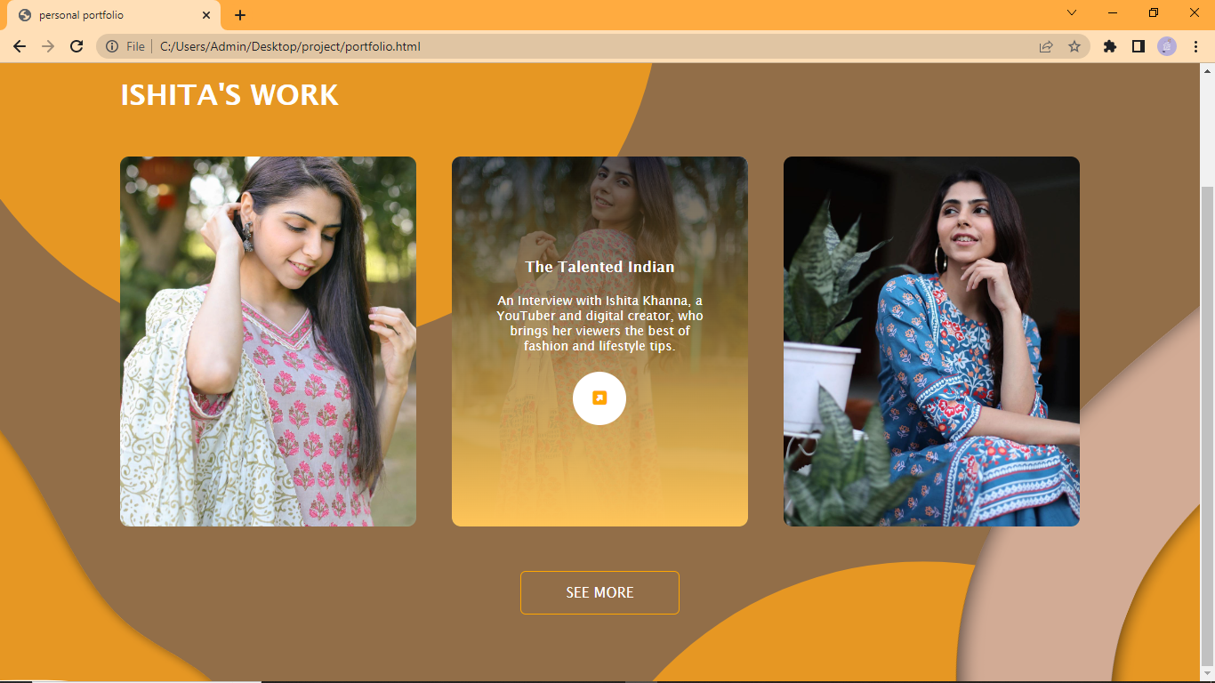

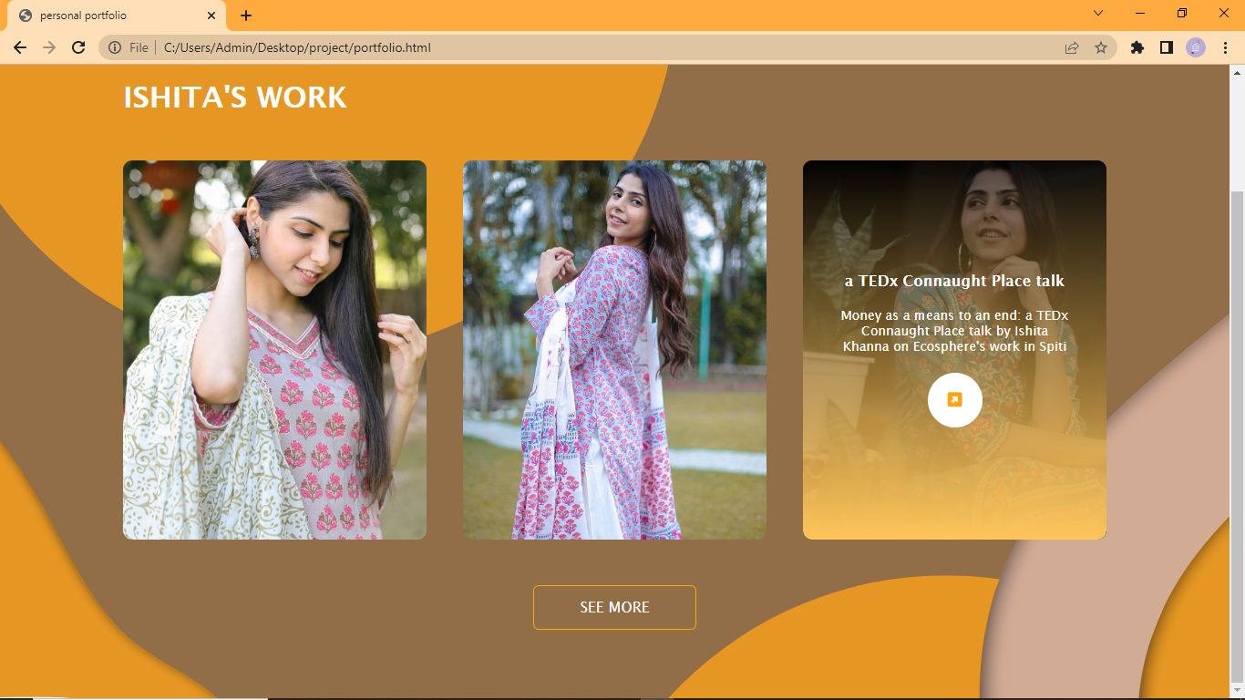

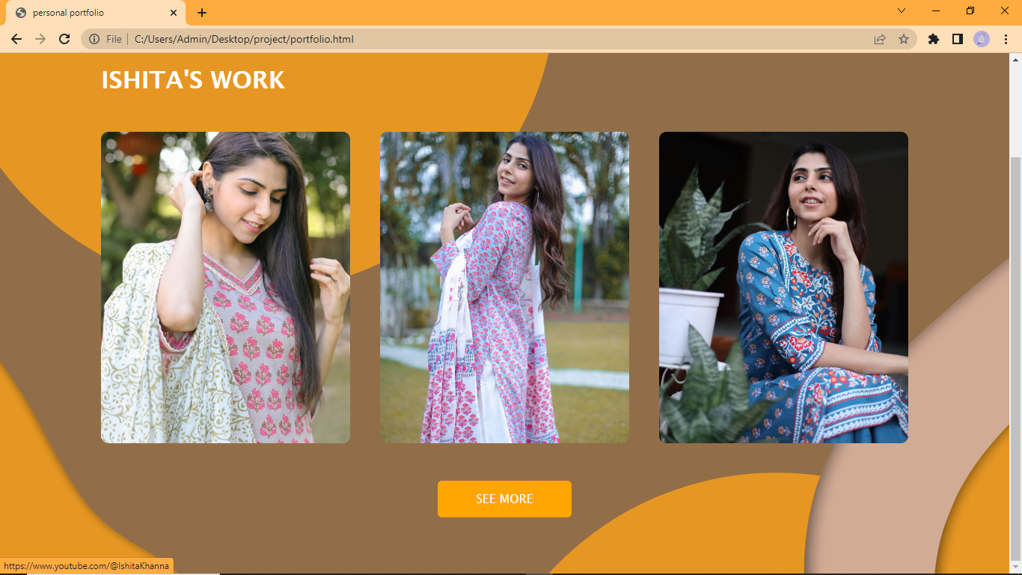

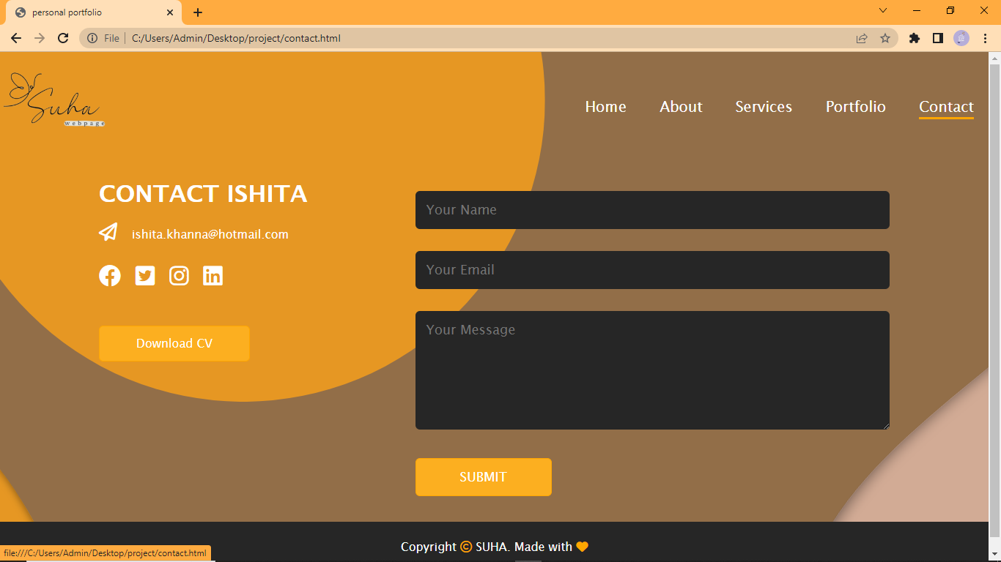

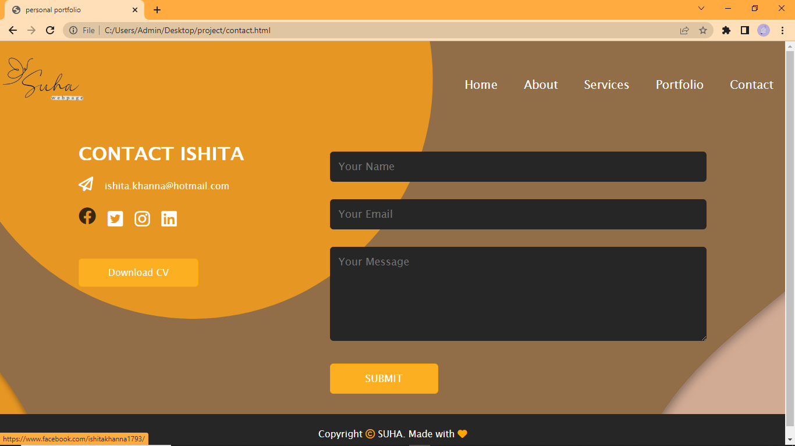

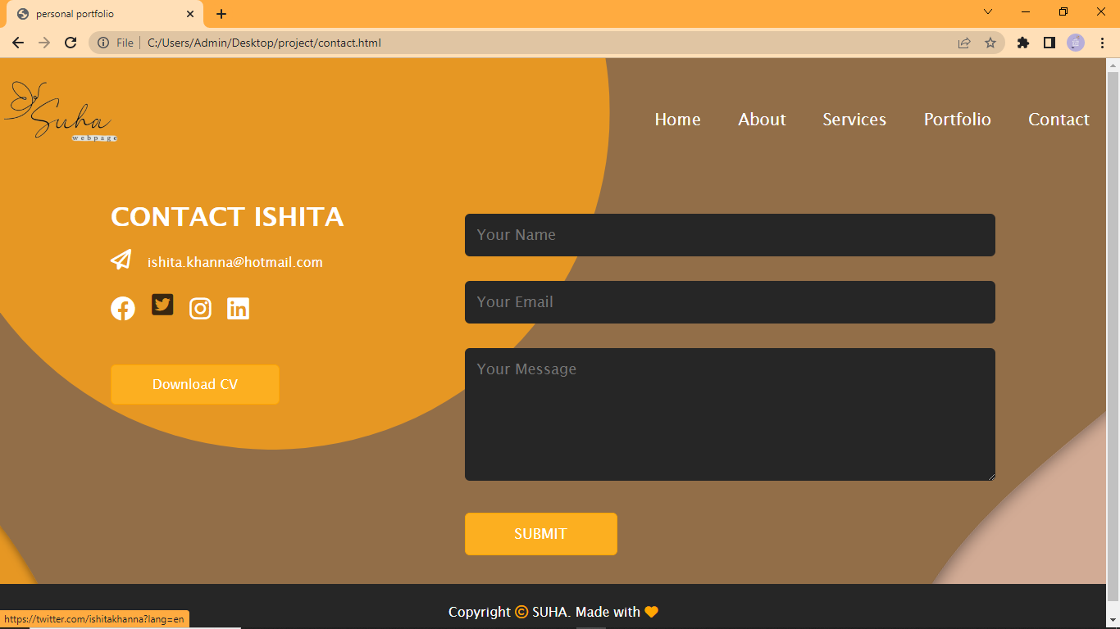

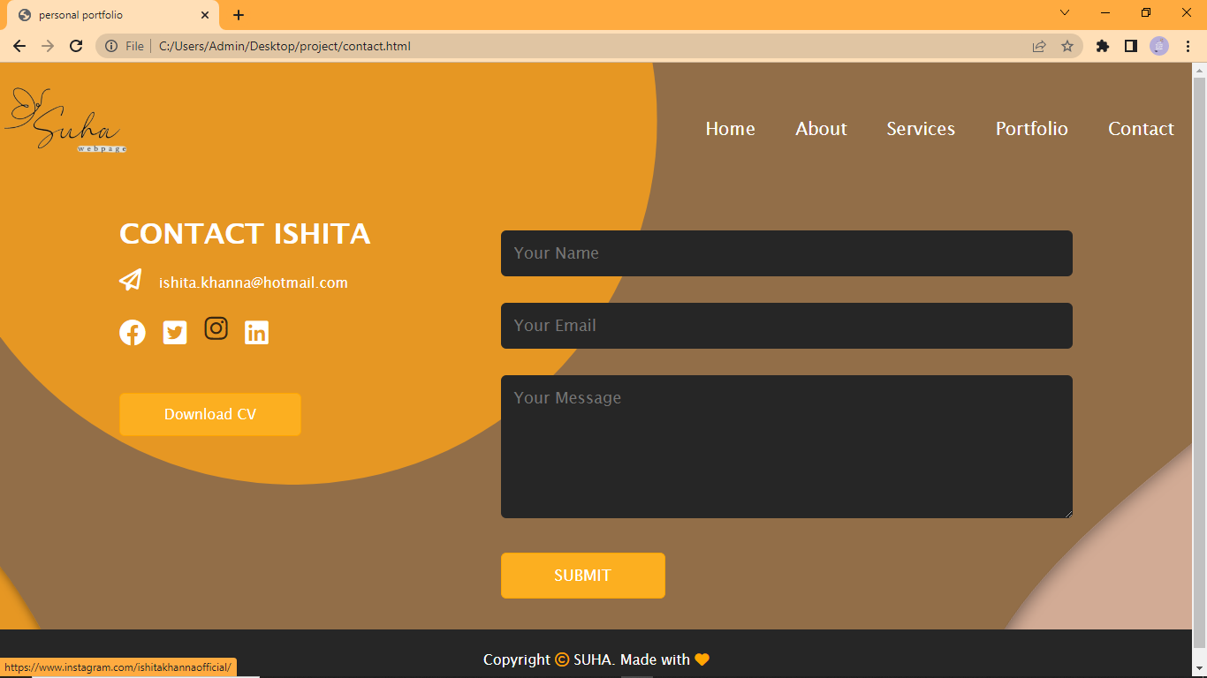

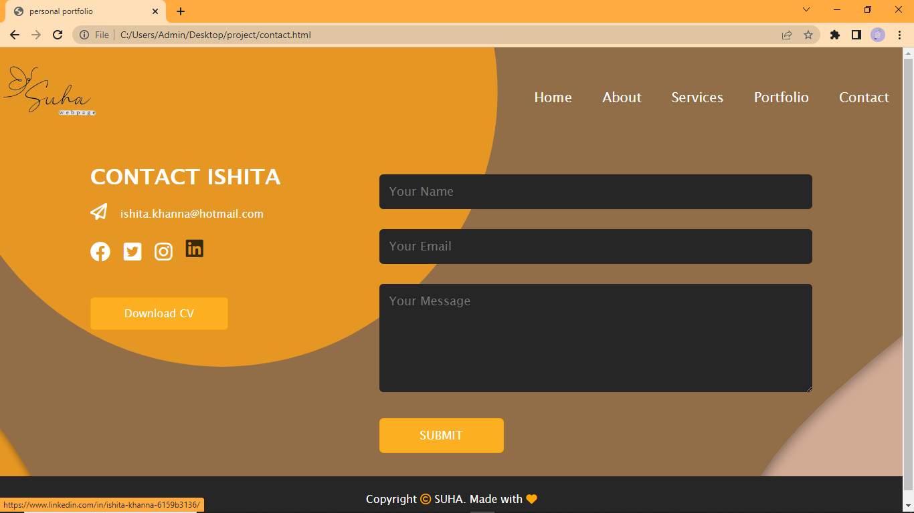

thank you